# THE PROJECT

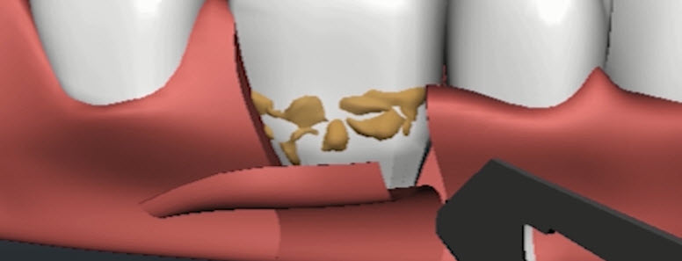PerioEndoscopy is a new Arizona Limited Liability Company (New Commercial Enterprise) that will design, manufacture and market a unique Dental Operative Unit (DOU) system that will provide dental clinicians the ability to SEE below the gum-line as they remove bacteria infested plaque. This procedure, known as Visual-SRP, is as effective as gingival flap surgery but without the pain and high costs of surgery.

Gingival (Gum) Flap Surgery

Visual-SRP – No Cutting, No Stitching

# FINANCIAL MODEL

The company will sell its $10,000 DOU directly to Dentists and Registered Dental Hygienists. Every time the DOU is used the Dental Clinicians use a factory sterilized disposable sheath. This recurring revenue generates an additional $50,000 to $150,000 revenue for PerioEndoscopy over the life of the DOU.

# BUSINESS MODEL

PerioEndoscopy, LLC will use qualified and FDA certified contract manufacturing to produce its products. Thus, maintaining lower overhead and lower costs overall.

# SALES AND MARKETING

The dental community is a finite and easily identifiable market. With PerioEndoscopy’s introduction of a high definition dental endoscope, the company will market directly to the known market. However, initial direct marketing will be made to the current dental users of a competitive DOU to capture the lucrative consumables revenue they currently enjoy. The national roll-out will be accomplished in geographic phases to concentrate sales resources in high value target areas. Specifically, there are six states that represent 33% of the market. Those six states will be the first to be addressed by the company’s direct sales employees.

# THE MARKET

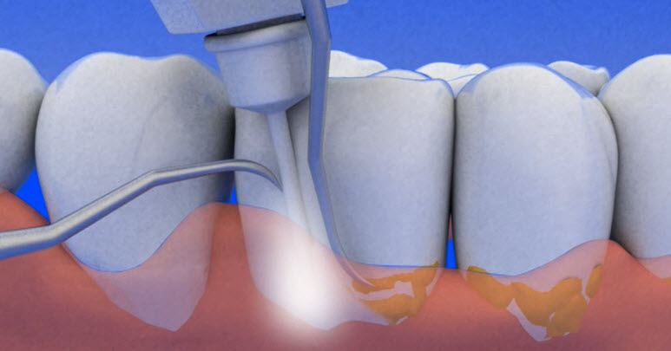In the United States alone there are 150,000 dentists and 200,000 dental hygienists. Full market penetration in the U.S. makes this a $3 Billion Market.

# Intellectual property

The company has filed two Provisional Patent applications to protect its design ideas. More patent opportunities exist and will be filed.

# FDA

The company’s DOU is a Class I Medical Device requiring only a 510k application without the time consuming and expensive clinical trials. The company will be able to go to market 90 days after the 510k application is submitted to the FDA.

# THE TEAM

The Management Team, supported by its board of directors represents extensive experience with start-ups and in the industry. The CEO, Michael Austin, has previously led two start-ups with successful exits. The company’s Chief Science Officer, Dr. Chad Kennedy, was formally the CEO of Restorative Biosciences. Board members include, Periodontal University Professors, practicing Periodontists and an Investment Banker, formerly on the board of Delta Dental.

# EB-5 INVESTOR

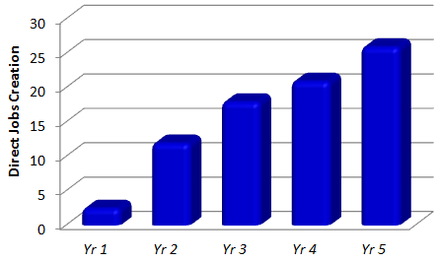PerioEndoscopy, LLC will accept one (1) EB-5 investor as a *Limited Partner with all the rights and responsibilities accorded under the Uniform Limited Partnership Act* as adopted by the State of Arizona in satisfaction of the “policy formulation” requirement of 8C.F.R. 204.6(j)(5)(iii) and as in agreement with EB-5 criteria. As a minimum *the EB-5 Investor* will have a seat on the board of directors with ***policy making responsibilities*.**

The EB-5 investor will receive a 16.67% stake in the company for the $500,000 investment. Return on Investment will be in accord with the EB-5 program. Correspondingly, the EB-5 Investor’s return, if any, will be calculated on the same basis as existing equity stake holders, based on the percentage of ownership of each stakeholder. The company’s Operating Agreement will include Buy/Sell criteria.

# EB-5 DIRECT INVESMENT

As a Direct Investment, where the need is for just one EB-5 Investor, the Investor’s equity goes to work immediately. No waiting for an indefinite period of time for the many other Regional Center EB-5 Investors to be identified and signed up for the same project.

# TARGETED EMPLOYMET AREA (TEA)

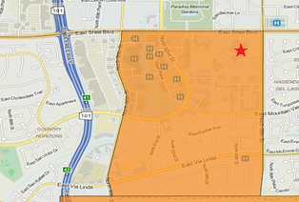The company is located in a census tract, certified by the Arizona Commerce Authority (ACA) as a TEA. This certification allows for an EB-5 Investor to invest at the current $500,000 minimum level.

# JOB CREATING ENTERPRISE

The company will hire an additional 10-12 Direct, Full-Time employees, within the first two years

# PRO-FORMA



# EB-5 COMPLIANCE

Compliance to EB-5 Criteria will be monitored by an Independent Third Party during the critical first two years of the Project, after EB-5 Funding.

# SHORT WINDOW OF OPPORTUNITY

The current EB-5 program expires September 30, 2015. The U.S. Congress’ indecision on the details of a renewed EB-5 Green Card program has resulted in a short term extension of the current program, maybe weeks, maybe months. However, it seems certain that the Minimum investment will increase to $800,000. Interested EB-5 Investors should act now if they wish to take advantage of the current $500,000 minimum investment.

# CONTACT INFORMATION

Michael Austin

[Michael@PerioEndoscopy.com](mailto:Michael@PerioEndoscopy.com) +1-480-717-4807

Julie Fletcher

[JFletcher@Lanick.com](mailto:JFletcher@Lanick.com) +1-(480) 406-0096